Programming Task

Git Repo Link: https://github.com/WaseemEng/su21-lab-starter/tree/main/lab04

This is factorial code in c for this I had write the risc v assembly code :

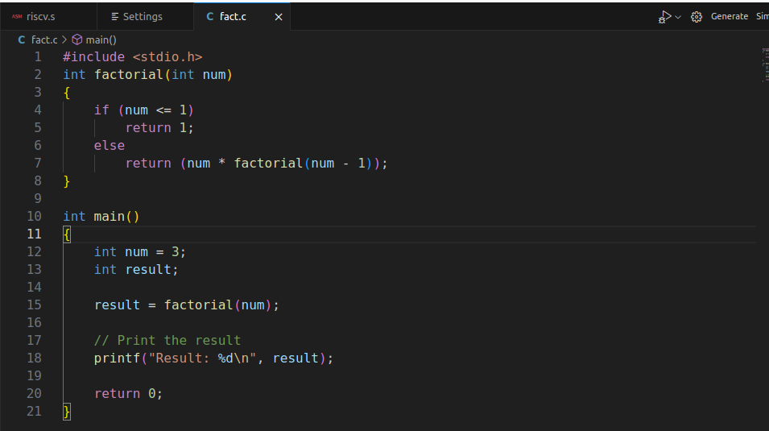
This is assembly code for above task:
.globl main

.text

main:
la t0, num
lw a0, 0(t0)

#prologue
addi sp,sp,-20
sw s0,0(sp)
sw s1,4(sp)
sw s2,8(sp)
sw s3, 12(sp)
sw ra,16(sp)

addi t0,x0,1
addi t1,x0,1
jal factorial # jum to factorial

exit:
lw s0, 0(sp)
lw s1, 4(sp)
lw s2, 8(sp)
lw s3, 12(sp)
lw ra, 16(sp)
addi sp, sp, 20 # remove the space on stack
addi a1, t0, 0
la s0,result #result in the S0 register
sw a0,0(s0)
j write_tohost # jump to write_tohost

factorial:
ble a0,t1,return
mv s0,a0
addi a0,s0,-1
addi sp,sp,-8
sw s0,0(sp)
sw ra, 4(sp)
jal ra, factorial
lw s0,0(sp)
lw ra,4(sp)
addi sp,sp,8
mul a0,a0,s0
jr ra

return:
addi a0,x0,1
jr ra

write_tohost:
li x1, 1
sw x1, tohost, t5
j write_tohost

.data
num: .word 4 #number for which I need to find the factorial
result: .word 0
.align 12
.section ".tohost","aw",@progbits;
.align 4; .global tohost; tohost: .dword 0;
.align 4; .global fromhost; fromhost: .dword 0;

Terminal Output:
when I run the code

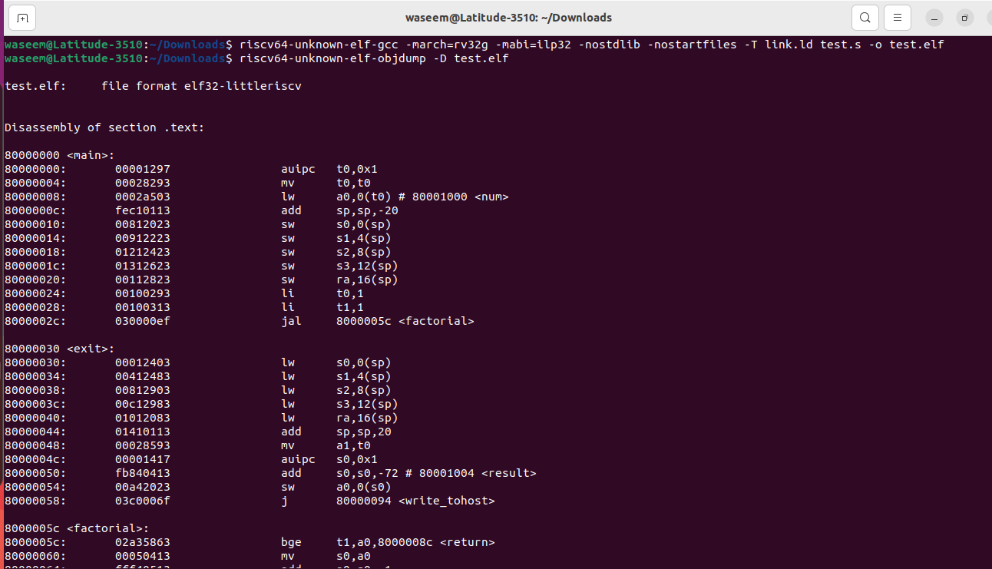
Log file:

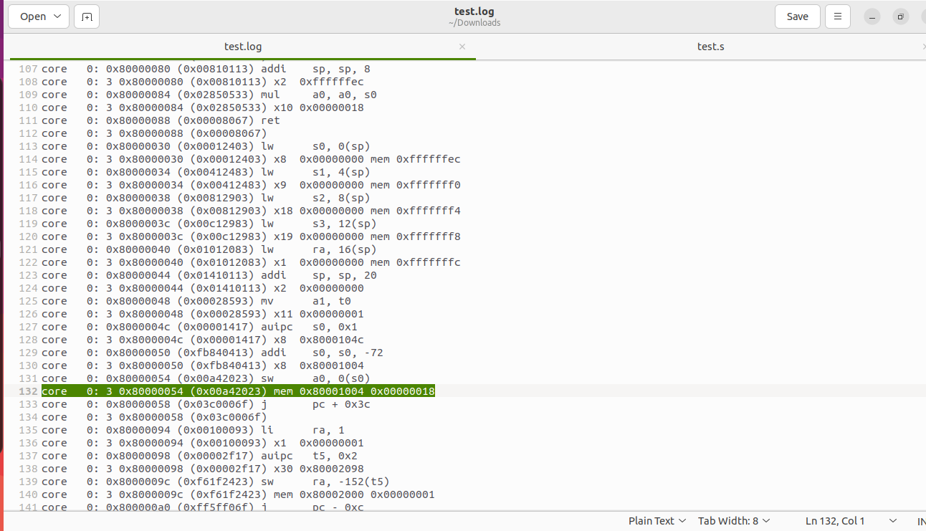
factorial of 4 is 24 which is 0x18 in hex and this shwon in the above and result store in s0 register.
4!=4*3*2*1=24

Linker file code:
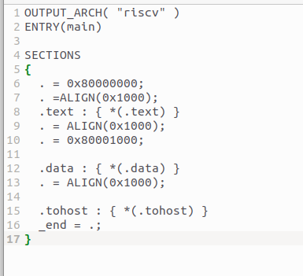

Block Diagram :
